**Supplementary Notes**

**An example of the method (cbFBA)**

As we said, a complex is a pattern of stoichiometry or, in other words, a linear combination of some metabolites that one or some reactions use or produce. For example, suppose there is a small metabolic network consisting of six metabolites and seven reactions shown in **figure 1(a)**. The desired metabolic network has nine complexes (**figure 1(b)**). **Table 1** represents the stoichiometry matrix of the model.

**Figure 1. (a) The metabolic network has six metabolites and seven reactions. Reactions r1 to r3 and r7 are exchange reactions. (b) Nine complexes are used or produced with the reactions r1 to r7.**

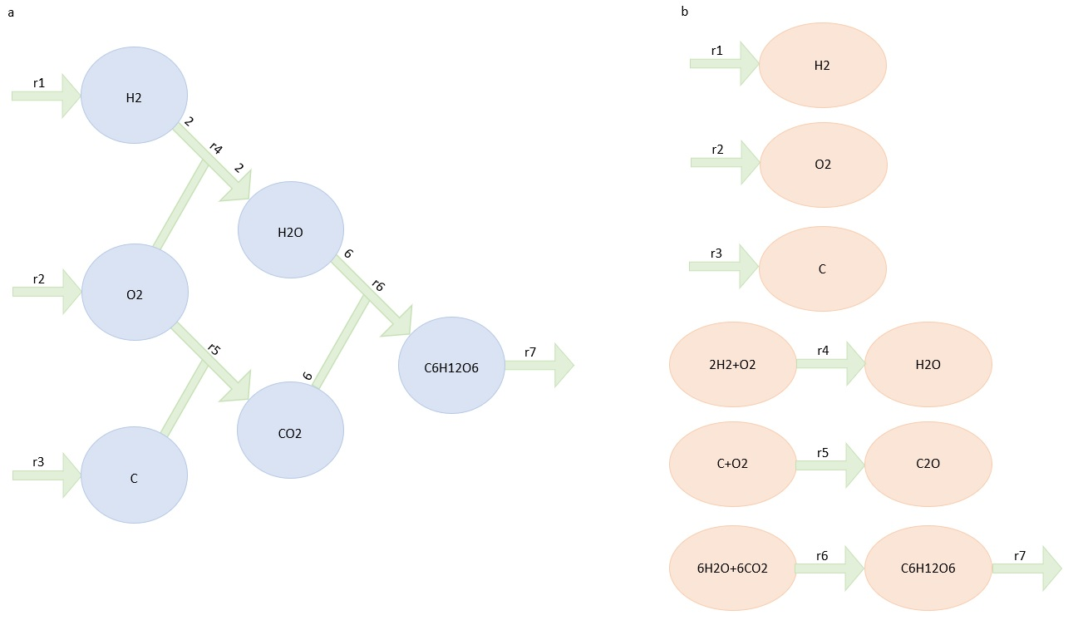

**Table 1. The stoichiometry matrix of a model with six metabolites and seven reactions.**

|  |  |  |  |  |  |  |  |
| --- | --- | --- | --- | --- | --- | --- | --- |
| **S matrix** | **v1** | **v2** | **v3** | **v4** | **v5** | **v6** | **v7** |
| h2 | 1 | 0 | 0 | -2 | 0 | 0 | 0 |
| o2 | 0 | 1 | 0 | -1 | -1 | 0 | 0 |
| c | 0 | 0 | 1 | 0 | -1 | 0 | 0 |
| co2 | 0 | 0 | 0 | 2 | 0 | -6 | 0 |
| h2o | 0 | 0 | 0 | 0 | 1 | -6 | 0 |
| c6h1206 | 0 | 0 | 0 | 0 | 0 | 1 | -1 |

The lower bound of all reactions is set to zero, except for the reaction $r_{7}$ That the lower bound is 0.5 mmol/g/h as biomass product. Also, the upper bound of all reactions is limited to 10 mmol/g/h. After applying FVA, the lower and upper bound of reactions measured for the model are shown in **Table 2.**

**Table 2. Reaction flux rate of the reactions in the model.**

|  |  |  |
| --- | --- | --- |
| **Reactions** | **Lower bound** | **Upper bound** |
| v1 | 3 | 6.67 |
| v2 | 4.5 | 10 |
| v3 | 3 | 6,67 |
| v4 | 1.5 | 3.33 |
| v5 | 3 | 6.67 |
| v6 | 0.5 | 1.11 |
| v7 | 0.5 | 1.11 |

We can define two matrices named $Y$ and $A$. The matrix $Y$ shows which metabolites contribute to which complexes. The matrix $A$ represents which complexes are used or produced by which reactions. The elements of the matrix $A$ are -1,0, and 1. The value -1 is for the reactions that take the complexes (incoming reaction), and 1 for reactions that use the complexes (outgoing reactions).

**Tables 3 and 4** show the matrices $Y$ and $A$, respectively. It is clear that the stoichiometry matrix $S=YA$.

**Table 3. Y matrix.** The rows refer to the metabolites and columns to the complexes.

|  |  |  |  |  |  |  |  |  |  |
| --- | --- | --- | --- | --- | --- | --- | --- | --- | --- |
| **Y matrix** | **H2** | **O2** | **C** | **2H2+O2** | **O2+C** | **2H2O** | **CO2** | **6H2O+6CO2** | **C6H12O6** |
| h2 | 1 | 0 | 0 | 2 | 0 | 0 | 0 | 0 | 0 |
| o2 | 0 | 1 | 0 | 1 | 0 | 1 | 0 | 0 | 0 |
| c | 0 | 0 | 1 | 0 | 0 | 1 | 0 | 0 | 0 |
| co2 | 0 | 0 | 0 | 0 | 1 | 0 | 0 | 6 | 0 |
| h2o | 0 | 0 | 0 | 0 | 0 | 0 | 1 | 6 | 0 |
| c6h1206 | 0 | 0 | 0 | 0 | 0 | 0 | 0 | 0 | 1 |

**Table 4. A matrix.** The rows refer to the complexes and columns to the reactions.

|  |  |  |  |  |  |  |  |
| --- | --- | --- | --- | --- | --- | --- | --- |
| **A matrix** | **v1** | **v2** | **v3** | **v4** | **v5** | **v6** | **v7** |
| H2 | 1 | 0 | 0 | 0 | 0 | 0 | 0 |
| O2 | 0 | 1 | 0 | 0 | 0 | 0 | 0 |
| C | 0 | 0 | 1 | 0 | 0 | 0 | 0 |
| 2H2+O2 | 0 | 0 | 0 | -1 | 0 | 0 | 0 |
| O2+C | 0 | 0 | 0 | 1 | 0 | 0 | 0 |
| 2H2O | 0 | 0 | 0 | 0 | -1 | 0 | 0 |
| CO2 | 0 | 0 | 0 | 0 | 1 | 0 | 0 |
| 6H2O+6CO2 | 0 | 0 | 0 | 0 | 0 | -1 | 0 |
| C6H12O6 | 0 | 0 | 0 | 0 | 0 | 1 | -1 |

We minimize the summation of absolute fluxes around complexes. The summation of each row of the $A$ matrix refers to the summation of fluxes around a complex. Then minimize the summation of absolute fluxes around complexes equals to minimize **equation 1** for our sample model.

$r_{1}+r_{2}+r_{3}+\left|r_{4}\right|+r_{4}+{|r}_{5}|+r_{5}+|r_{6}|+\left|r_{6}-r_{7}\right|$***equation 1***

The complex C6H12O6 is a balanced complex. It means the reactions $r_{6}$ and $r_{7}$ carry the same flux, then $\left|r_{6}-r_{7}\right|=0$. **Equation 1** gets the smaller value equal to 24 mmol/g/h. because the possible reaction rate for reaction $r_{7}$ is 0.5 mmol/g/h. Then the reactions $r_{1}$ to $r_{6}$ will get the flux value 3,4,5,3,1.5,3, and 0.5 mmol/g/h respectively.

**The pseudocodes and algorithms to solve the problem.**

First, we are minimizing the summation of absolute flux around complexes. Then, we solve linear programming to find the minimum value of the summation of absolute flux around complexes; then, we apply FVA to find the flux cone of the metabolic networks of strains under the condition that the summation of absolute flux around complexes is minimum.

**Step 1.**

$$m=min∑|c|$$

s.t.

$$Nv=0$$

$$v_{lb}≤v≤v_{ub}$$

$$c_{i}= \sum_{j=1}^{|v|}{a_{ij}}; a_{ij}∈A$$

**Step 2.**

$$\min{v_{i}}$$

s.t.

$$Nv=0$$

$$v_{lb}≤v≤v_{ub}$$

$$c_{i}= \sum_{j=1}^{\left|v\right|}{a_{ij}}; a_{ij}∈A$$

$$\sum_{i=1}^{|A_{1}|}{{|c}_{i}|=m}$$

Then we minimized the flux summation of all reactions in the metabolic network. First, similar to cbFBA, we solve linear programming to find the minimum value of the summation of reaction fluxes; then, we apply FVA to find the flux cone of the metabolic networks of strains under the condition that the summation of reaction fluxes is the minimum.

**Step 1.**

$$m=min∑v$$

s.t.

$$Nv=0$$

$$v_{lb}≤v≤v_{ub}$$

**Step 2.**

$$\min{v_{i}}$$

s.t.

$$Nv=0$$

$$v_{lb}≤v≤v_{ub}$$

$$\sum_{i=1}^{|v|}{v_{i}=m}$$

$v$ isthe vector of reactions ( $v_{i}$ refers to the reaction number th ).

isthe vector of the lower bound of reactions.

$v_{ub}$ isthe vector of the upper bound of reactions.

$c$ isthe vector of complexes ( $c_{i}$ refers to the complex number th ).

isstoichiometric matrix.

$A$ is a matrix in that rows refer to complexes and columns refer to reactions. ( $a_{ij}$ refers to the th complex and th reaction.)